Arctic Outbreak – February 9-20, 2021
By: Don Wheeler, Meteorologist
Bayou State Weather, LLC



Wednesday, February 3, 2021 would mark the day a historically cold Arctic air mass began its plunge southward into the United States out of Canada. The cold air would grip the nation for nearly three weeks with sub-freezing temperatures into south Texas. Temperatures plummeted to below zero well into north Texas where widespread power outages occurred. A few stations in northwest Louisiana also went sub-zero. Co-op observation stations Bienville (Bienville Parish) and Plain Dealing (Bossier Parish) both recorded -1 F on the morning of February 16. Nashville, Arkansas (Howard County) in southwest Arkansas fell to -13 F! (Source: National Weather Service – Shreveport, LA). The extreme cold temperatures on the night of February 15 into the morning hours of the February 16 were enhanced by the widespread snow cover and clear skies which allowed for efficient radiational cooling.

While the initial surge of Arctic air began on February 3, it did not make it to Louisiana until the morning of February 9. Even then, the shallow nature of the cold air would encounter the higher terrain of the Ouachita Mountains of western Arkansas and eastern Oklahoma, thus preventing a direct plunge of the cold air into the state. Slowly, the depth of the cold air thickened with height allowing it to penetrate all the way into the Gulf of Mexico. All but extreme southeast Louisiana experienced sub-freezing temperatures on the mornings of February 14 and 15 with all areas of the state below the 32-degree mark on the morning of February 16. Most areas of north Louisiana saw freezing or sub-freezing temperatures in excess of 100 consecutive hours. Monroe recorded 141 consecutive hours at or below freezing from 5PM February 13 to 2PM February 19 which was an all-time record for Monroe. Shreveport recorded 110 consecutive hours at or below the freezing mark.

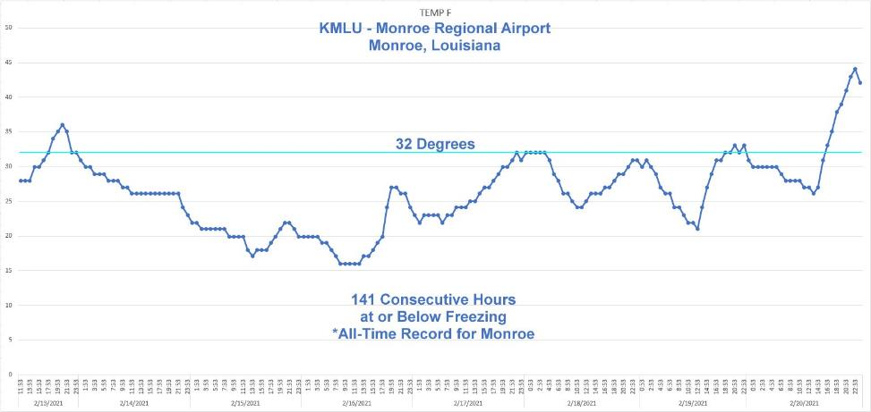
Monroe, Louisiana recorded 141 consecutive hours at or below 32 degrees setting an all-time record.

Due to the prolonged period of sub-freezing temperatures, precipitation was sure to fall. Louisiana and surrounding areas experienced two winter storms within a week. The first was primarily a snow producer for Louisiana and the second produced a mix of snow, sleet, and freezing rain. Snowfall totals with the first system on February 14-15 generally produced 2-6” totals across north Louisiana with some locally higher amounts over extreme northwest Louisiana and lesser amounts across the eastern river parishes of northeast Louisiana.

The second system saw warmer air advect northward above the cold air at the surface resulting in more of a freezing rain and sleet event for much of northeast Louisiana as well as northcentral Louisiana along and south of the I-20 corridor. Snow was the predominant precipitation type closer to the Arkansas border. Portions of southwest Arkansas saw 9-13” of snow from near Texarkana to Hope. Even so, areas of extreme northwest Louisiana saw 3-5” of snow with the second event. Because of the close timing of the two winter weather episodes, north Louisiana saw a rare accumulation of snow/sleet before complete melting from the first storm. Storm totals for both events saw 2-4” along and south of the I-20 corridor and 4-10” near the Arkansas border over northwest Louisiana.

Winter Storm #1

Long-range computer models began to pick up on a potential snow event in the 7-10 day time frame. Initially the GFS, ECMWF, and Canadian models all were showing a significant snow event across north Louisiana with mixed winter precipitation further south. In time the ECMWF model began to back away from the low temperatures as well as the winter precipitation; however, it eventually returned to align with the GFS and the Canadian models. As usual, the GFS was somewhat bullish with the forecast lows at the onset of the cold outbreak, in some cases showing lows between 0 and -6 over north Louisiana just beyond the 7-day time frame.

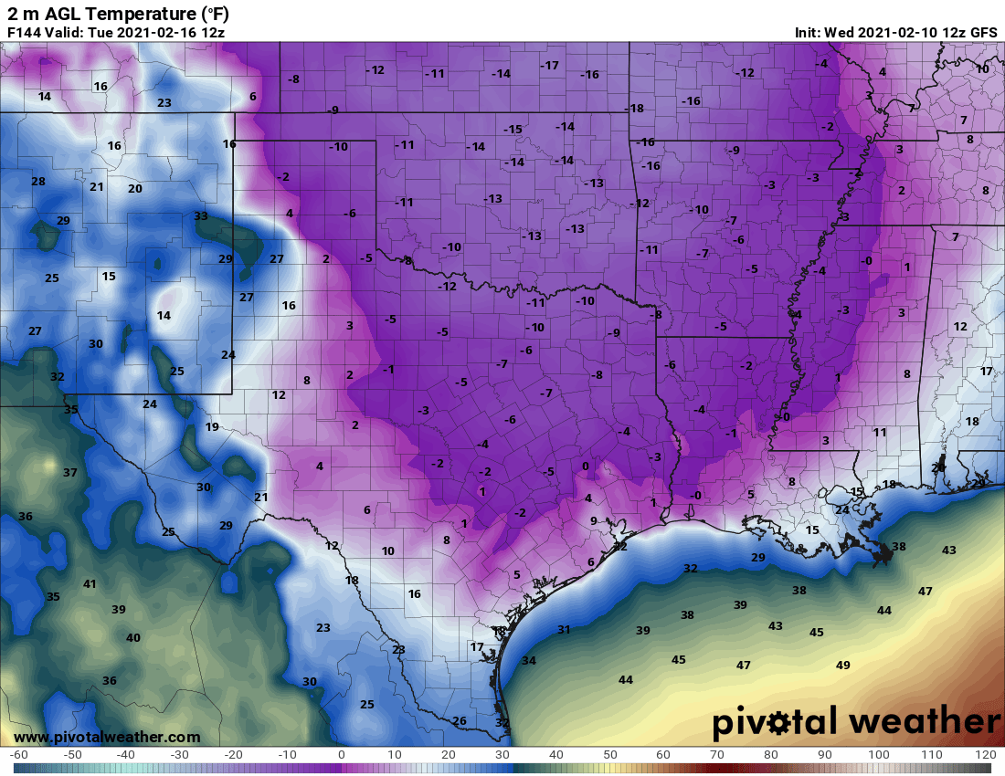
12Z 2/10/2021 Run of GFS Forecasted Lows for 2/16/2021

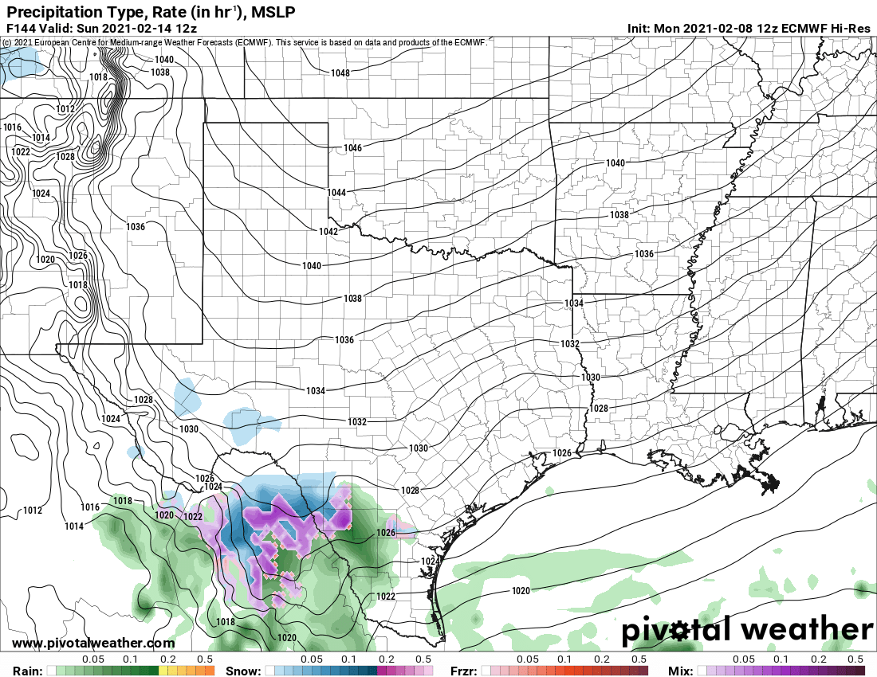  ECMWF 12Z Run 02/08/21 | 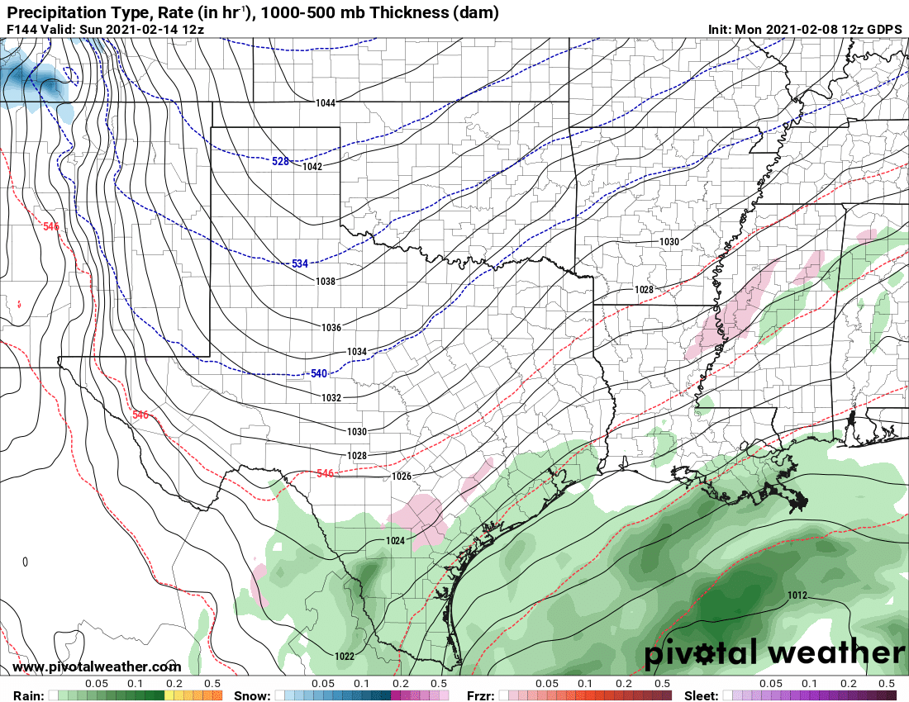  GDPS 12Z Run 02/08/21 | 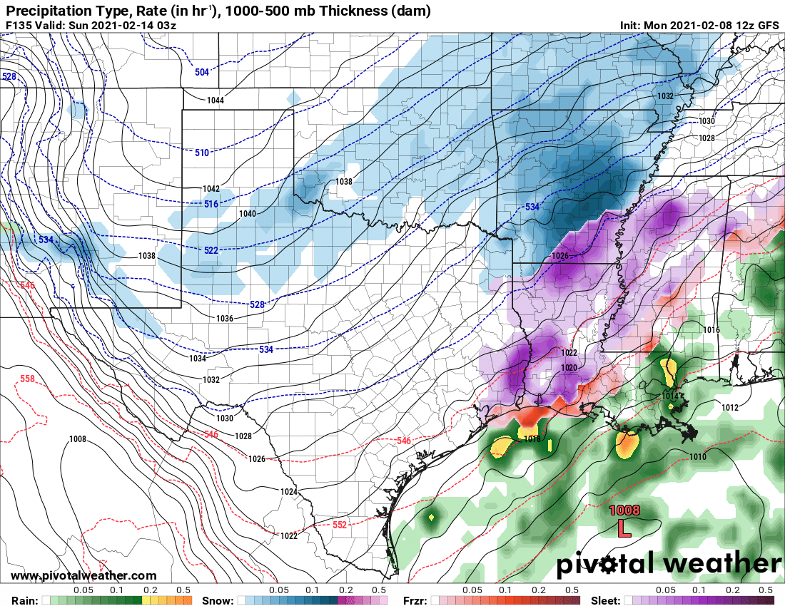  GFS 12Z Run 02/08/21
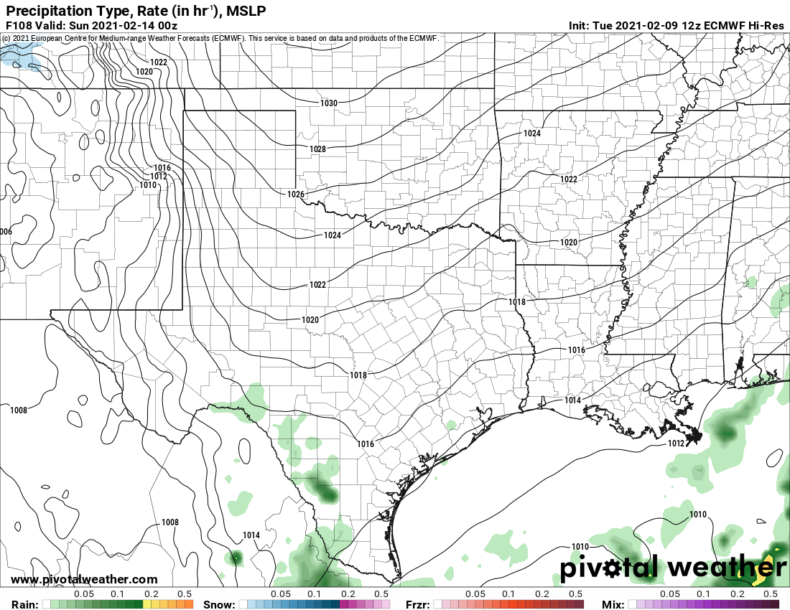  ECMWF 12Z Run 02/09/21 | 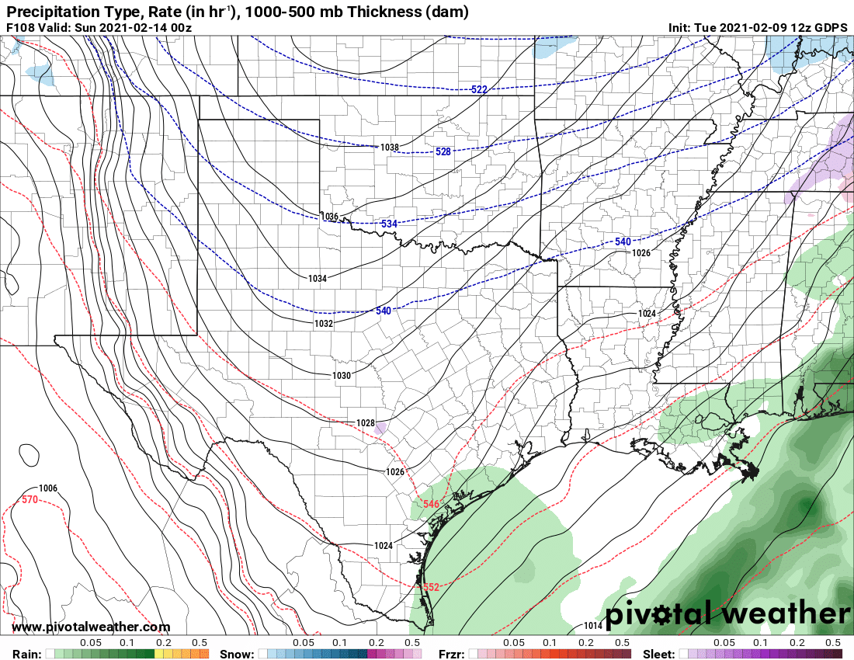  GDPS 12Z Run 02/09/21 | 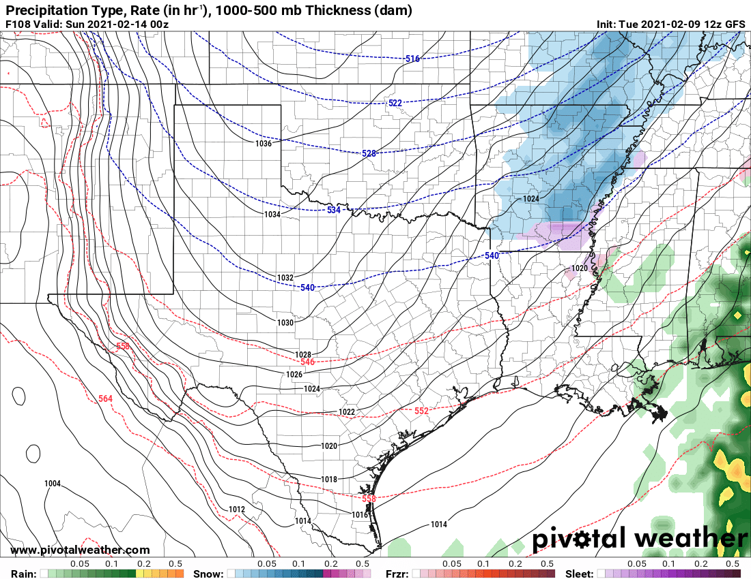  GFS 12Z Run 02/09/21
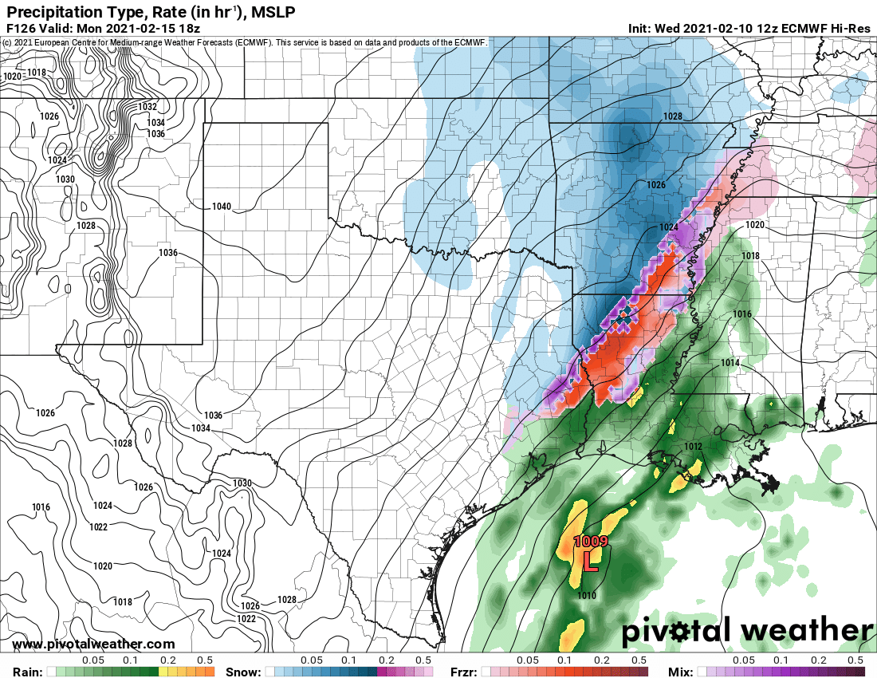  ECMWF 12Z Run 02/10/21 | 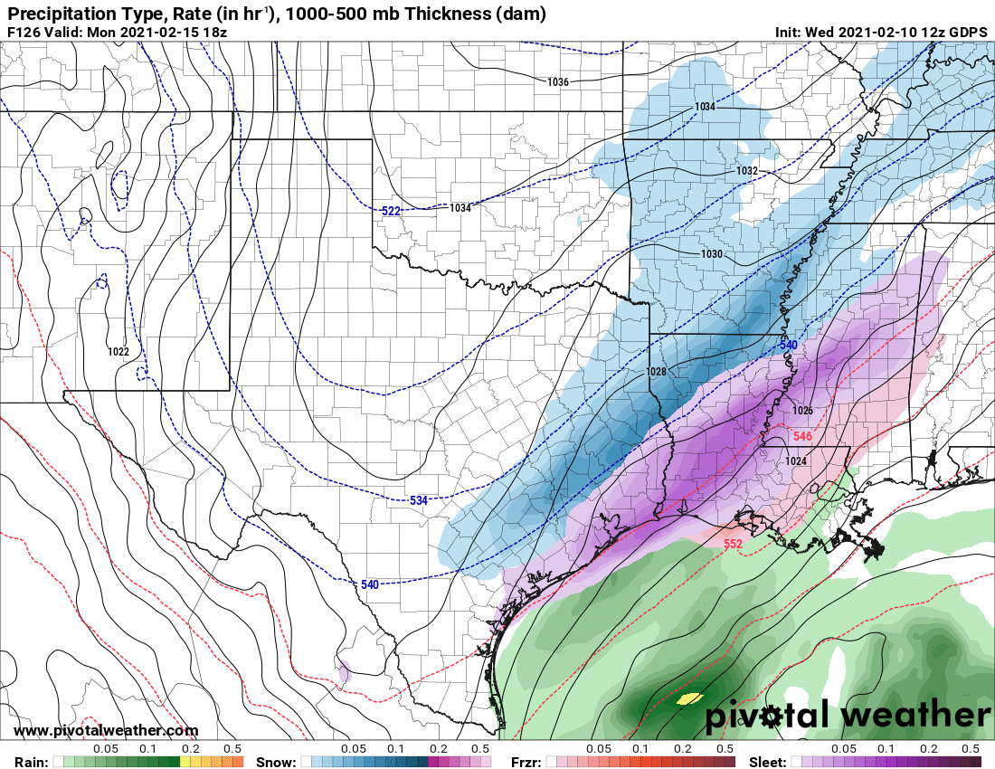  GDPS 12Z Run 02/10/21 | 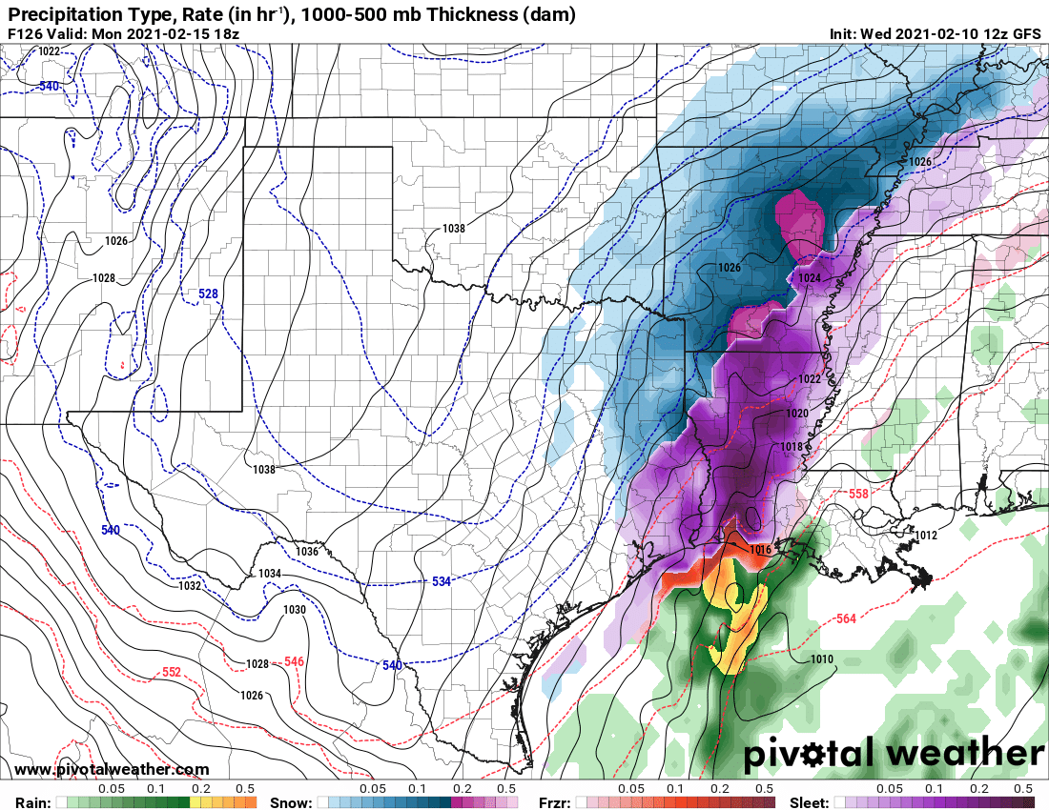  GFS 12Z Run 02/10/21
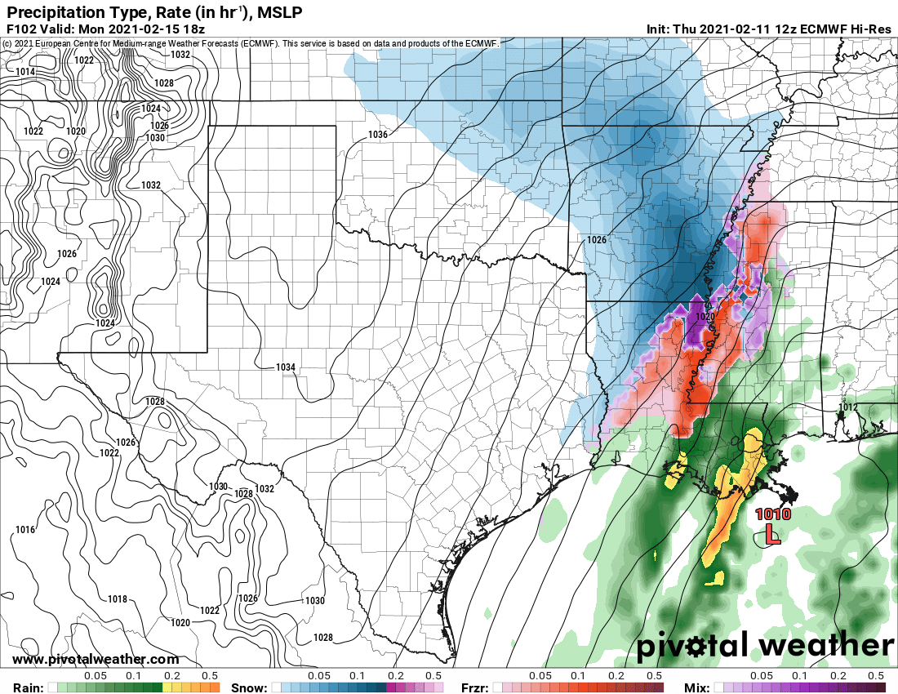  ECMWF 12Z Run 02/11/21 | 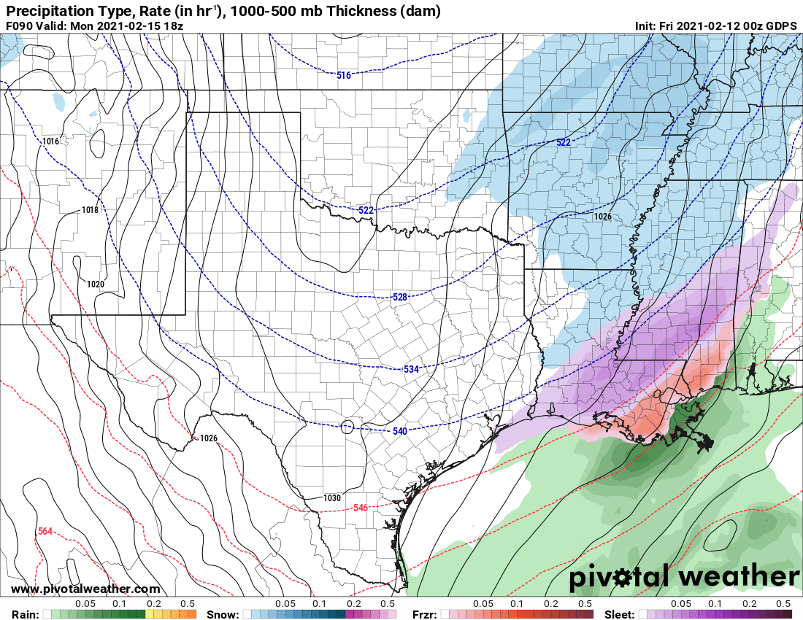  GDPS 12Z Run 02/11/21 | 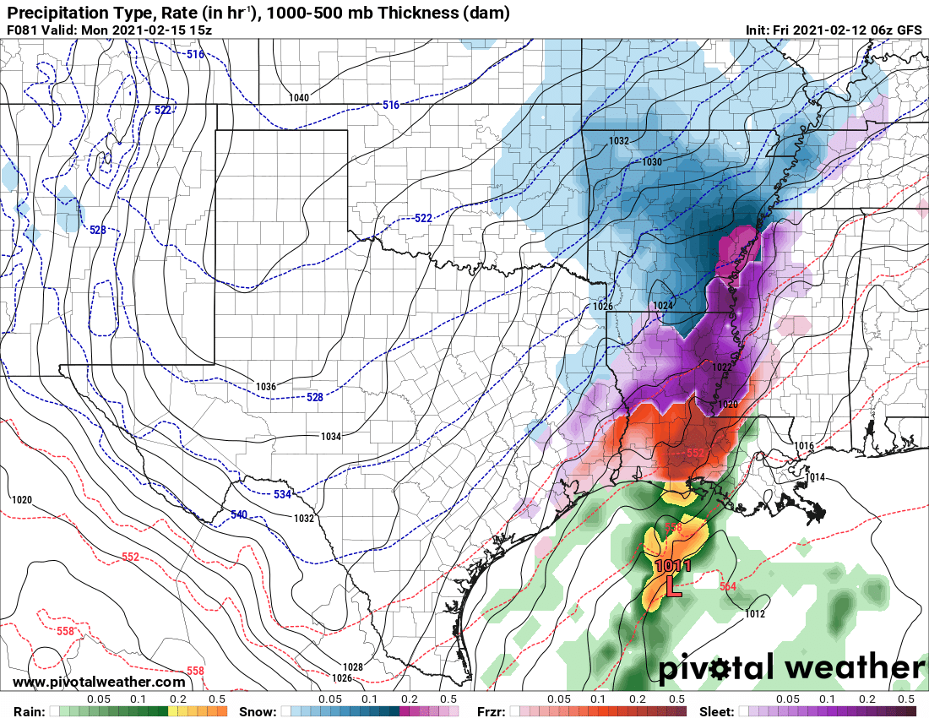  GFS 12Z Run 02/11/21
In the table above, each column represents model runs of the first winter storm with column 1 the ECMWF, column 2 the GDPS, and column 3 the GFS. The model runs were initiated at 12Z on February 8, 9, 10, and 11. Note the discrepancies for the ECMWF and the GDPS with the runs on February 8 and 9 as compared to the more aggressive GFS. Both the ECMWF and the GDPS came into more alignment with the GFS with the 12Z runs on February 10 and 11.

The 0Z model runs for Sunday, February 14 were very consistent in showing significant snowfall totals across north Louisiana as well as adjacent areas of Arkansas and Texas. There were also indications that freezing precipitation would extend well south into the state, perhaps as far south as southwestern coastal areas.

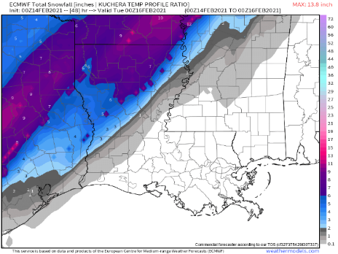 | 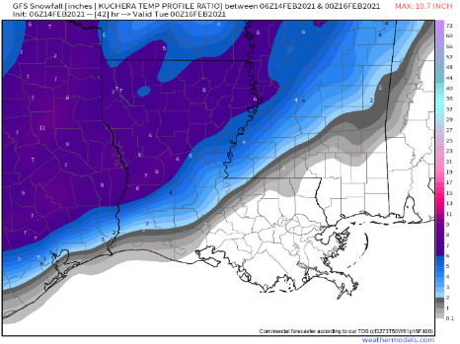
EMCWF (left) and GFS (right) Forecast for 0Z Tuesday 2/16/2021

Forecast totals ranged from 3-6” across most locations with some locally higher amounts forecast. Some of the precipitation, especially along and south of I-20 and across northeast portions of the state, was to forecast to begin as a light freezing rain/sleet mix as the cold air aloft deepened. Forecast totals from the National Weather Service in Shreveport were in agreement with model guidance showing light sleet and freezing rain with the onset of the precipitation with a changeover to all or nearly all snow. Ice accumulation of less than ¼” were anticipated with the higher amounts over northeast Louisiana followed by a swath of snow in the 4-6” range over north-central Louisiana.

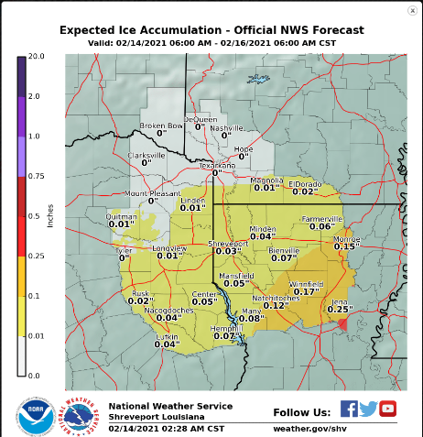 | 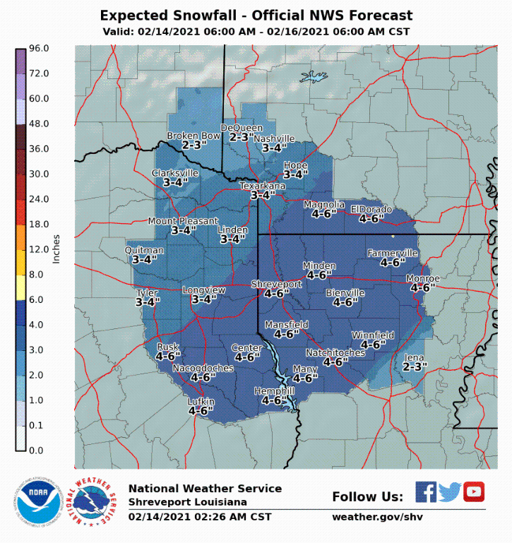
Forecast Ice/Snow Totals from NWS-Shreveport.

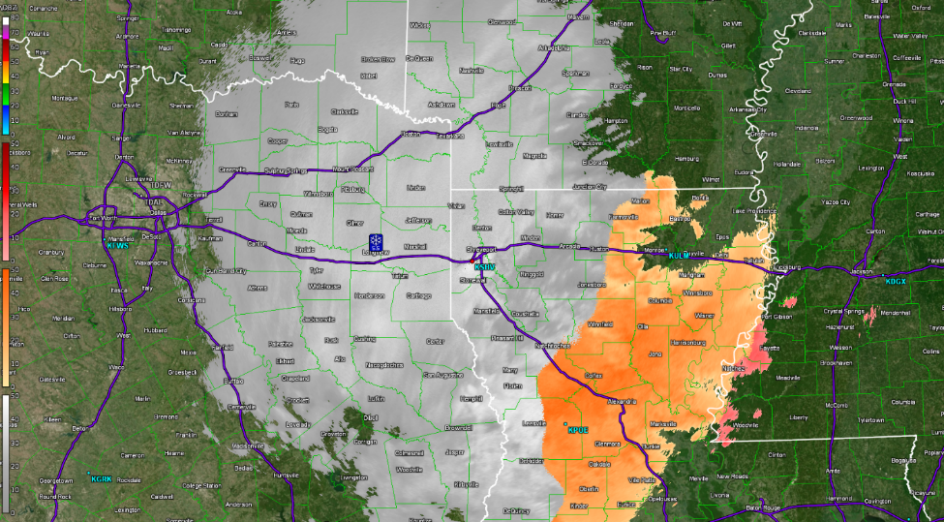
Snow and some sleet began in east Texas during the early morning hours, Monday, February 15 and spread east. Precipitation quickly changed to all snow across northeast Texas and northwest Louisiana with a sleet/freezing rain mix over north Louisiana.

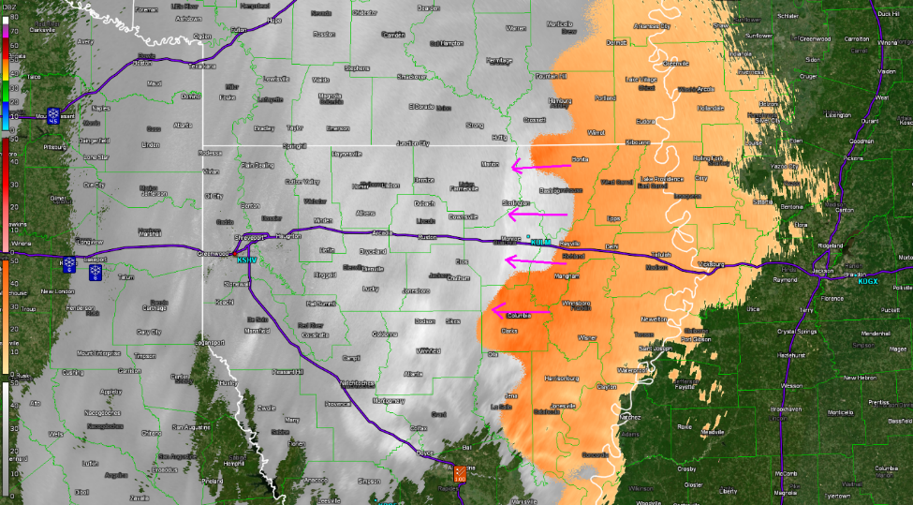
The transition to all snow continued across much of northcentral and northeast Louisiana during the early afternoon hours. Radar at 1PM showed the transition line (indicated by arrows) as it pushed east. Further east across extreme northeast Louisiana and into Mississippi, much of the precipitation remained sleet and freezing rain.

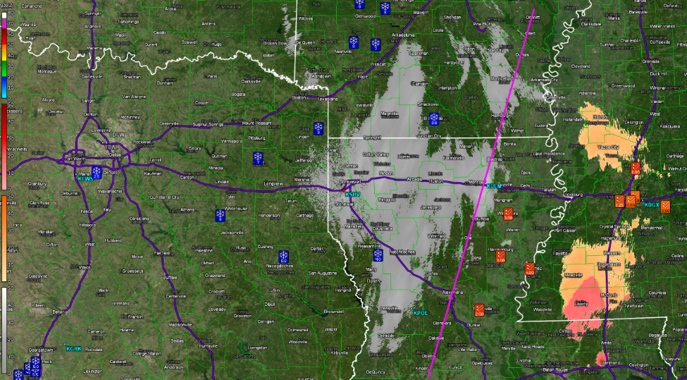
Reports to the National Weather Service indicate where the general snow/sleet & freezing rain line set up. West of the diagonal line mostly snow fell then transition to more sleet and freezing rain east of the line.

Upper air soundings from 12Z (6AM CST) on the morning of February 15 supported the distribution of precipitation types. The Shreveport sounding showed the column of air above it was entirely below the freezing line. Further east, the Jackson sounding showed warm air above the surface at 2,400 feet with subfreezing temperatures near the surface. This vertical profile was the perfect setup for freezing rain and sleet

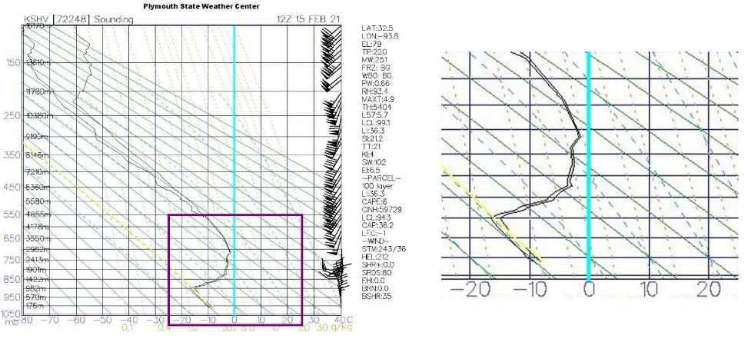
KSHV 12Z Sounding 2/15/2021. Note the temperature is freezing (left of blue 0C/32F line) through the atmosphere.

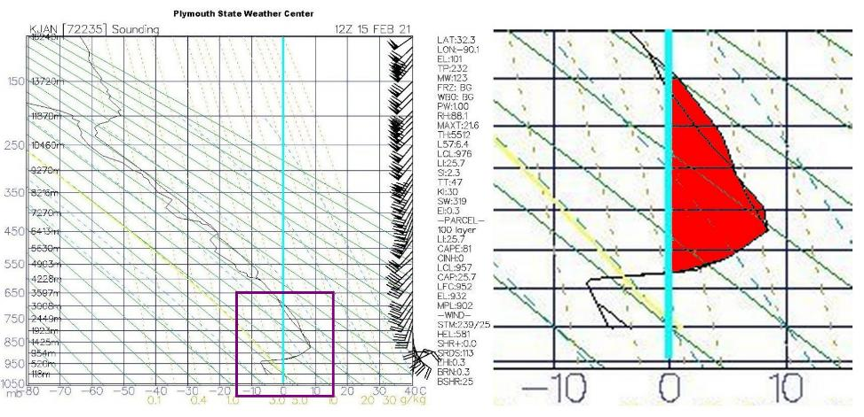
KJAN 12Z Sounding 2/15/2021. Note the “Warm Nose” above the surface freezing level (red shading to the right of the blue 0C/32F line).

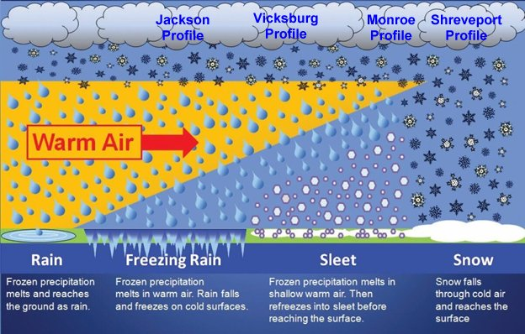
Atmospheric Setup for Winter Weather. View is Looking from East to West. Shreveport’s profile indicated all snow with a gradual change to winter mix conditions as one traveled east.

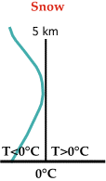 | 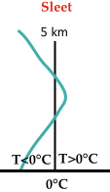 | 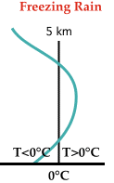
Vertical profiles showing temperatures for snow, sleet, and freezing rain. Compare the snow profile to the KSHV sounding and the sleet and freezing rain profiles to the KJAN sounding.

Actual snow and ice accumulations reported to the National Weather Service in Shreveport indicated a general swath of 2-4” over northcentral Louisiana from Toledo Bend northeast to Monroe. Higher totals were found over extreme northwest Louisiana and into northeast Texas.

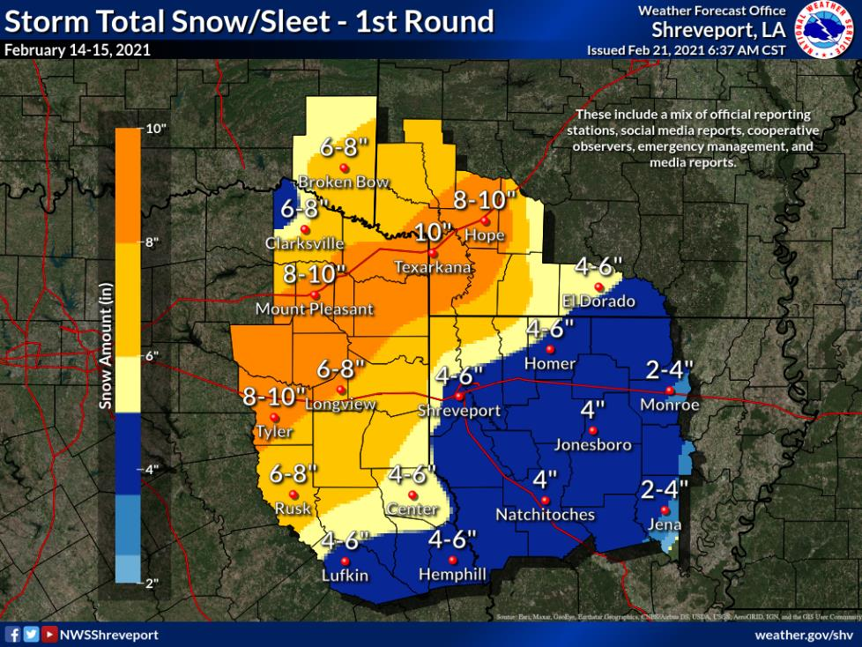

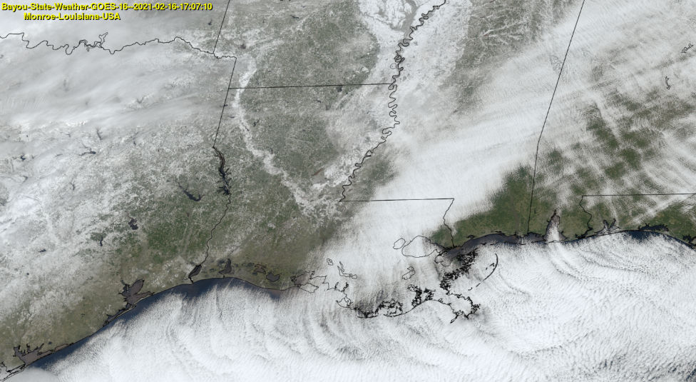
High-Resolution GOES Image from Bayou State Weather Showing Snow/Ice to the Southeast Texas and Southwest Louisiana Coastal Areas.
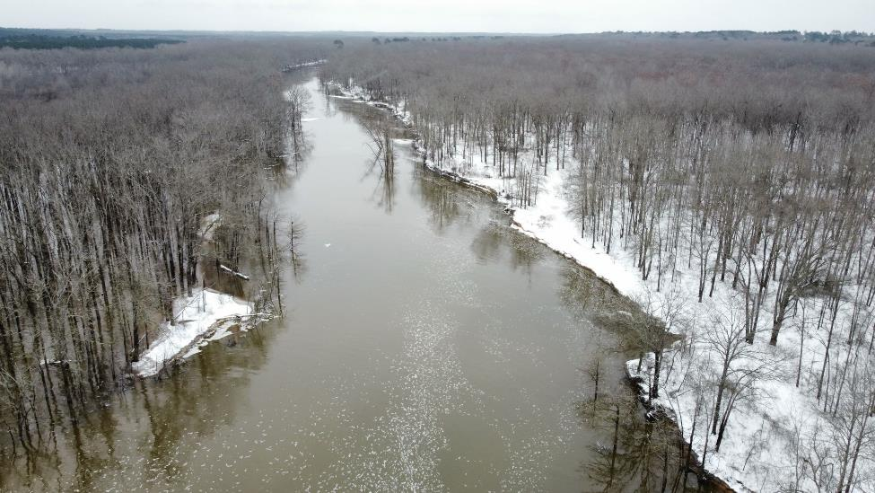
Snowfall along Bayou D’Arbonne in Union Parish – Drone Footage Courtesy of Burt Green

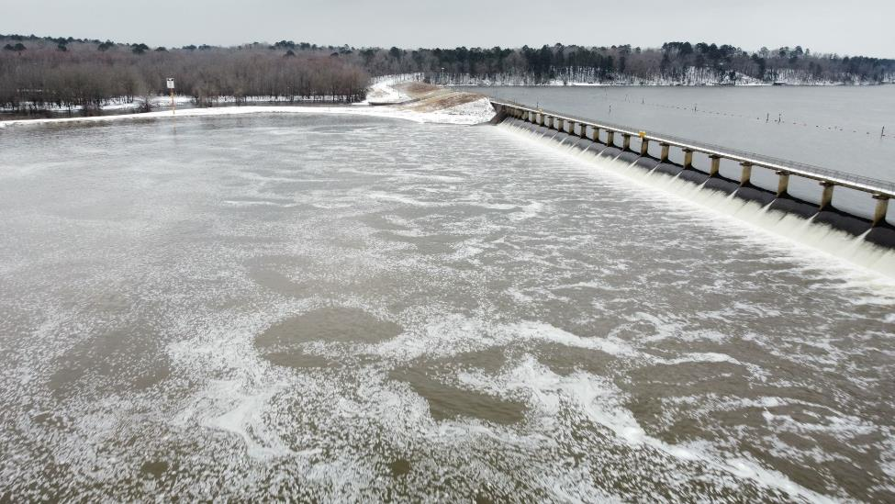
Snowfall along Bayou D’Arbonne in Union Parish – Drone Footage Courtesy of Burt Green

Winter Storm #2

Winter storm warnings for the first storm had not yet expired before they were re-issued for north Louisiana and adjacent areas for the next round of winter weather. Computer models had been showing the development of a surface low in the northwestern gulf that would track east-northeast along the upper Texas and Louisiana coasts in response to a deepening upper trough just to the west. With the second system, indications were that circulation around the low would draw warm air from the gulf up and over the cold air at the surface and create more of an icing event for much of north Louisiana with the transition line from mixed winter precipitation to snow along the Louisiana/Arkansas border.

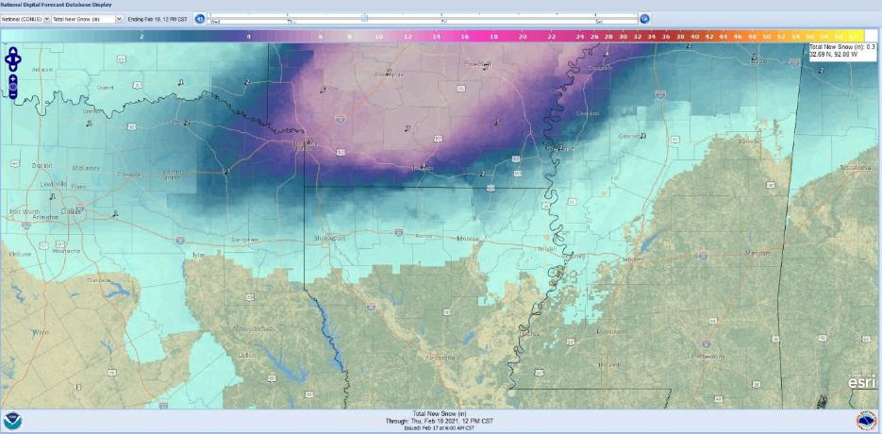
National Weather Service Forecast Snow Totals for the Event

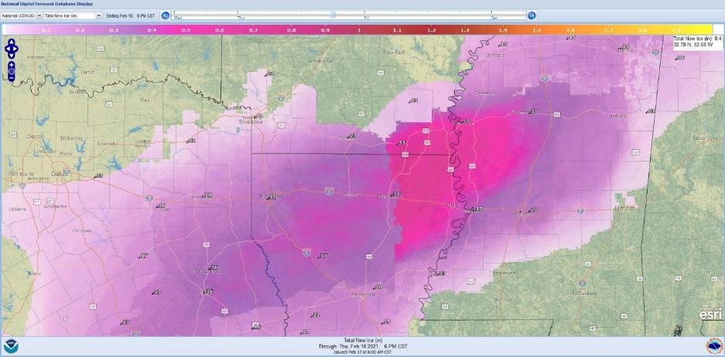
National Weather Service Forecast Ice Totals for the Event

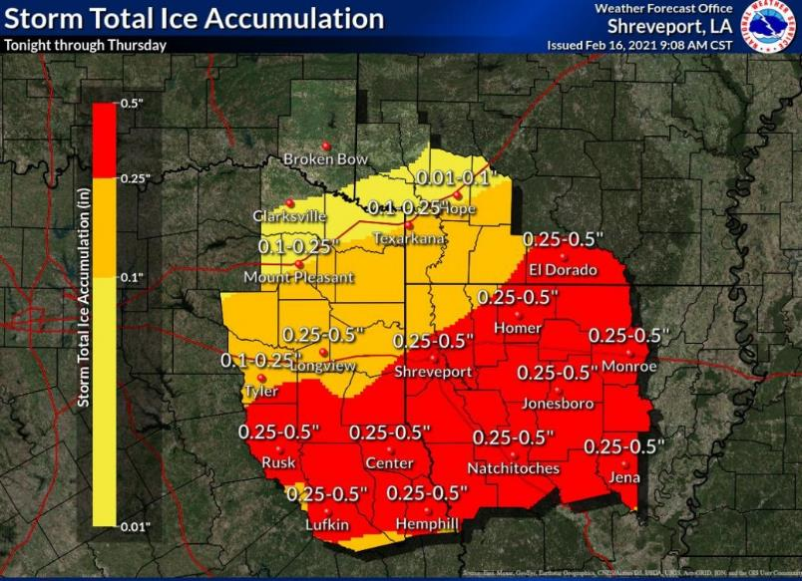
Forecast Ice Accumulation – NWS Shreveport

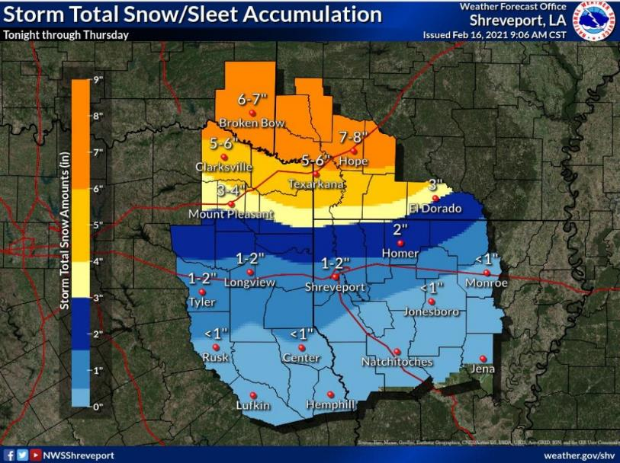
Forecast Snow Accumulation – NWS Shreveport

Indeed, that is what happened. 12Z soundings from both Shreveport and Jackson on the morning of February 17 indicated that warm air was advecting north above the cold layer. Lake Charles, closest to the gulf, showed a very pronounced warm nose only 1,200 feet above the surface. Even though the 12Z soundings at Shreveport and Jackson showed only a small warm nose at the time of observation (6AM CST), the readings were taken early in the warm air advection process; therefore, further warming of the column continued, especially over eastern sections of the state and into Mississippi. This warming was verified as the initial onset of precipitation was primarily sleet across the I-20 corridor before transitioning to more freezing rain as the day progressed.

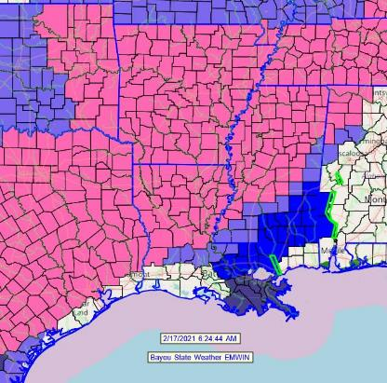
Early morning surface maps and upper level charts were all pointing at a significant icing event for much of north Louisiana with a significant snow event further north into Arkansas. Winter storm warnings (pink) were in place for the northern half of the state with winter weather advisories (light blue) just south and east of the warning area.

The 500mb map at 12Z on February 17 showed a large trough across the central part of the country digging well south into northern old Mexico. At the surface, an area of low pressure was located just off the central Texas coast with a surface warm front extending east of the low and a cold front extending south.

Surface winds across the state were from the east and northeast in response to circulation around the low. Temperatures at 12Z were in the lower 20s over north Louisiana to lower 30s over much of south Louisiana. By mid-afternoon, the surface low had moved east-northeast and was located off the Louisiana coast south of Lafayette. Temperatures had warmed over much of the state to the lower 30s over north Louisiana to the low and mid 30s over southwest Louisiana. Warm air had surged into southeast Louisiana ahead of the low pressure where temperatures had risen in the 50s and 60s.

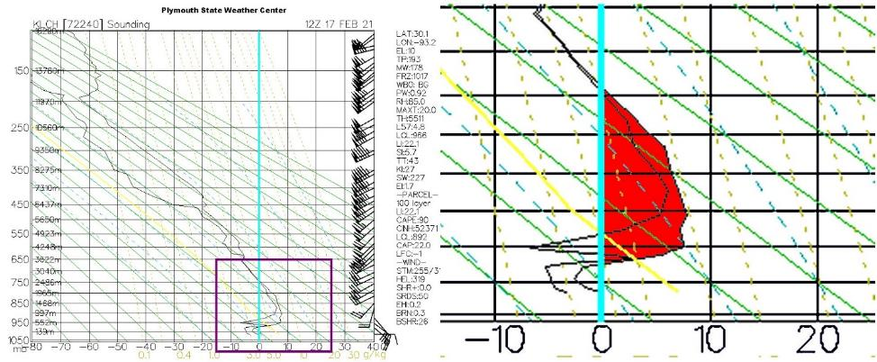
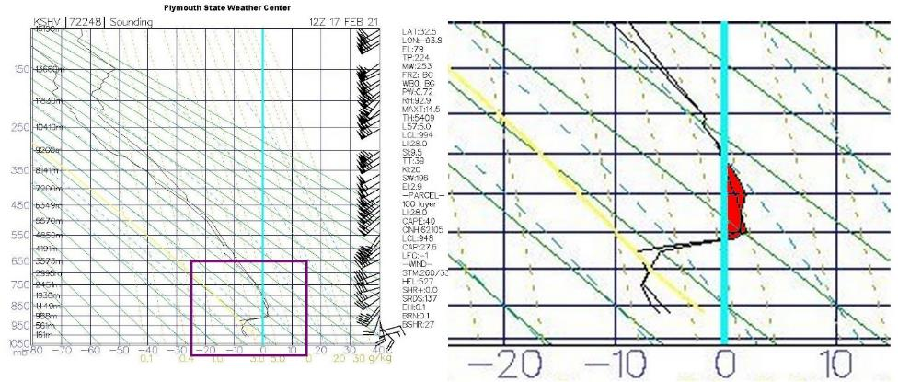
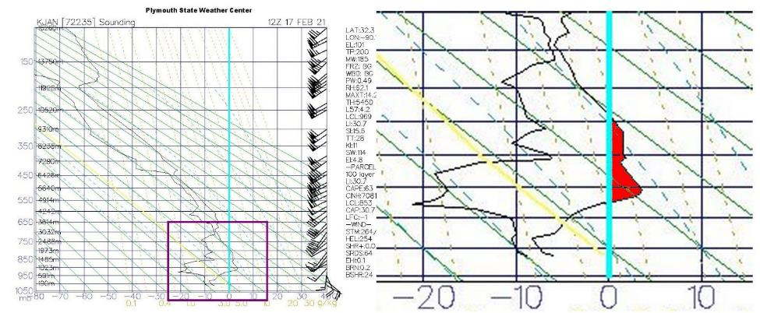
12Z (6AM CST) soundings from Lake Charles (top), Shreveport (middle), and Jackson (bottom) showing warm air advecting northward up and over the cold airmass at the surface in response to developing low pressure in the northwest gulf.

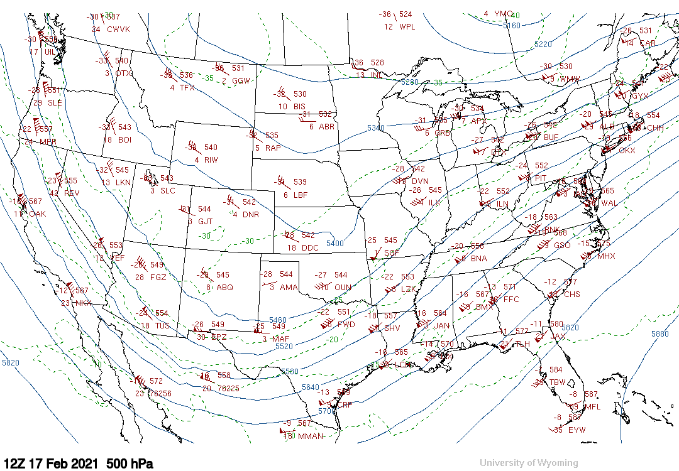
500mb map at 12Z February 17 showing large trough across central U.S.

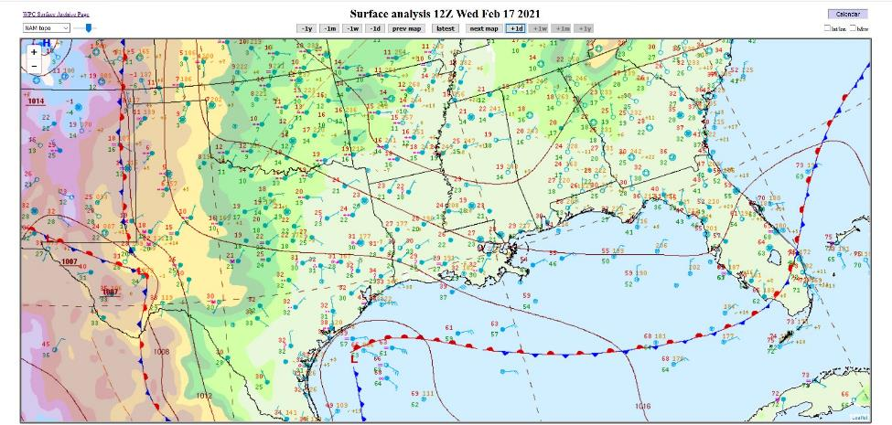
Surface map at 12Z (6AM CST) February 17 showing developing area of low pressure off of the Texas coast.

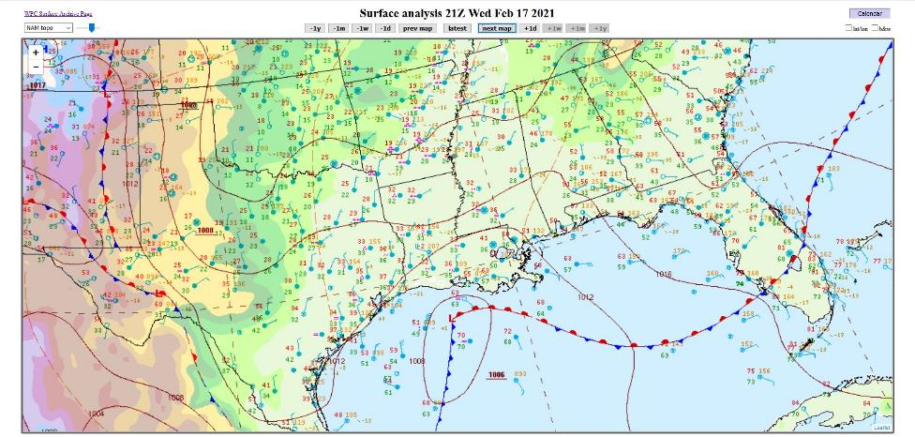
Surface map at 21Z (3PM CST) showing the area of low pressure off the Louisiana coast.

Precipitation began to quickly push northward during the early morning hours of February 17. Enhanced radar imagery showed the “general areas” that were receiving snow, sleet, and freezing rain. Freezing rain and sleet reports were posted throughout the morning hours over all of north Louisiana with northwest portions of the state reporting more snow than sleet/freezing rain.

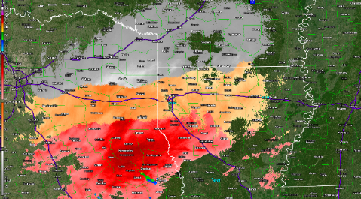  KSHV 1222Z (6:22AM) 2/17/21 | 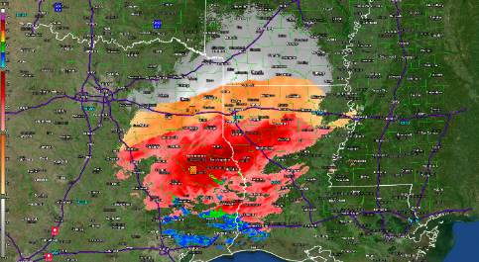  KSHV 1347Z (7:47AM) 2/17/21
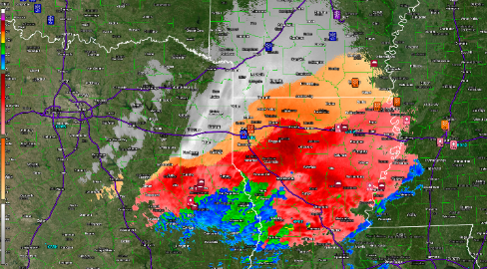  KSHV 1943Z (1:43PM) 2/17/21 | 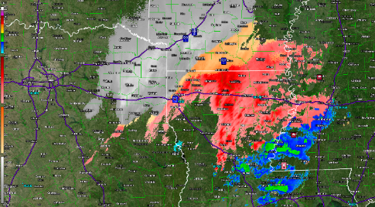  KSHV 2258Z (4:58PM) 2/17/21

As forecast, snow totals were confined primarily to the Louisiana/Arkansas border areas along and north of I-20. Some impressive snow amounts were noted in southwest Arkansas where some locations saw over one-foot of additional snow. Ice accumulations were generally in the ¼ to ½ inch amounts with slightly higher totals in a small swath across east-central areas of northeast Louisiana from Winn Parish across Caldwell, northern LaSalle, Franklin, Madison, and Tensas Parishes.

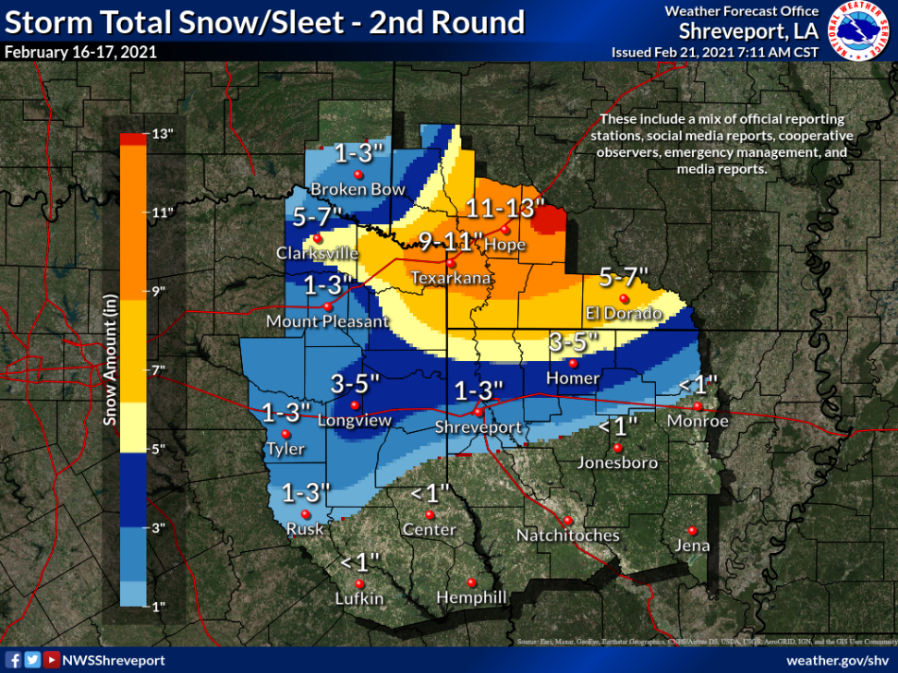

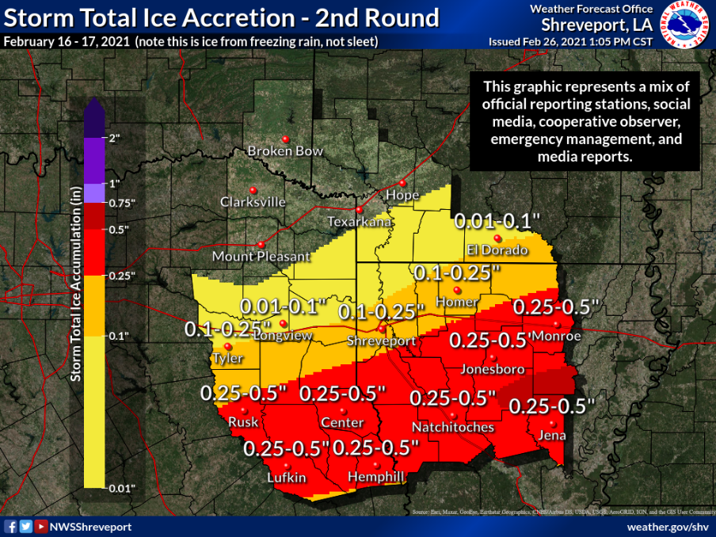

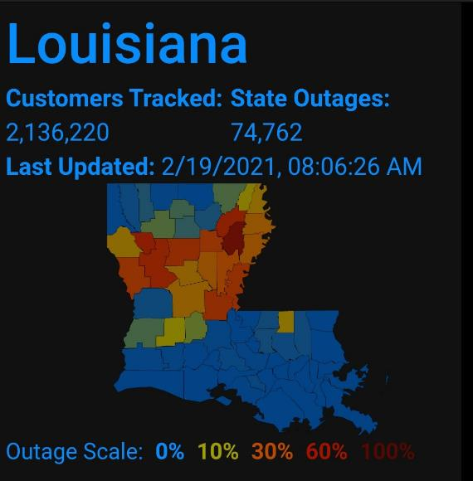
Liquid totals during the second event were quite impressive as well with many stations across north Louisiana recording from 1 to nearly 1.5” of liquid equivalent precipitation. The combination of freezing rain and sleet on the ground amounted to ¼ to ½ inch with lesser amounts across northwest Louisiana where more snow fell. Actual ice accumulation on exposed objects (trees, powerlines, etc.) generally were around ¼” or less but with some locally higher values. This was enough to cause tree limbs to snap resulting in power outages across much of north Louisiana. Note the more numerous outage area was where the majority of the fallen precipitation was in the form of freezing rain that nicely corresponds to the storm total ice accretion map. In addition to the power outages, many locations across north Louisiana experienced water outages due to a combination of excessive water leaks and power disruption.

Summary

Surprisingly, forecast models were quite accurate in forecasting the two winter systems that affected our state. As will all winter systems, actual amounts did vary just a bit from actual forecasted amounts and in the case of snow totals in south Arkansas, underestimated those amounts. It is important to emphasize that long-range computer models are to be used for tendency only, especially beyond the 7-day period. In this case, many models were indicating this event quite early; however, past experience dictated to exercise patience. All area meteorologists, as well as National Weather Service Offices, performed an outstanding job handling this event.

Select Images of Icing across Northeast Louisiana

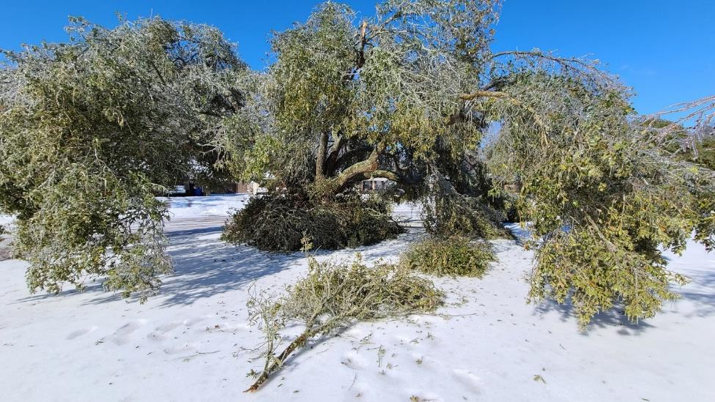
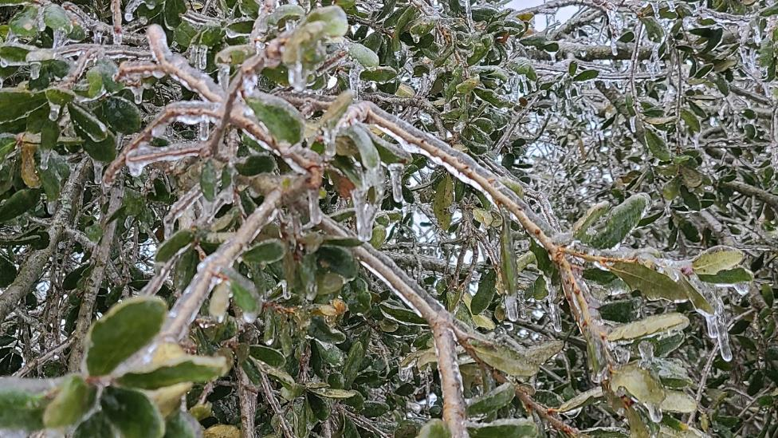
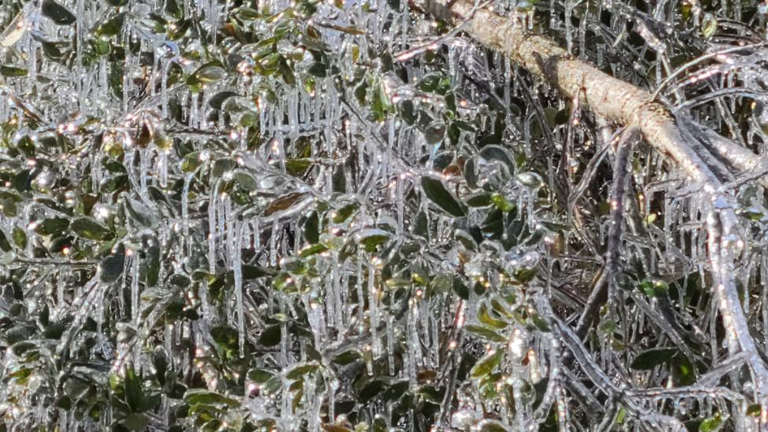
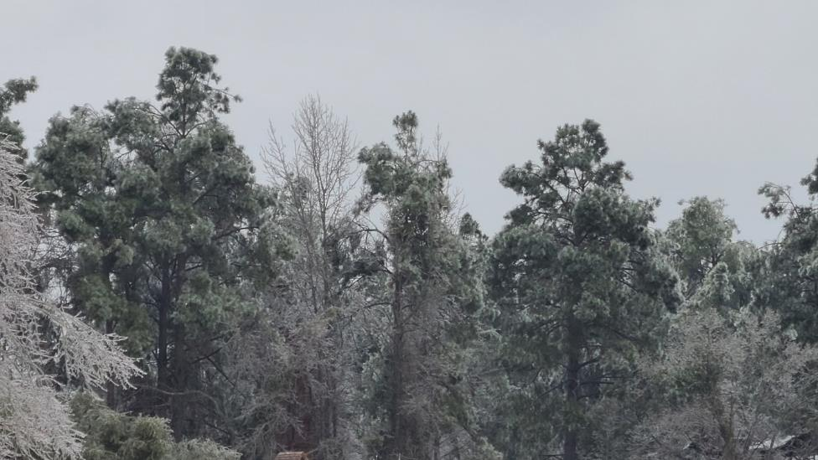
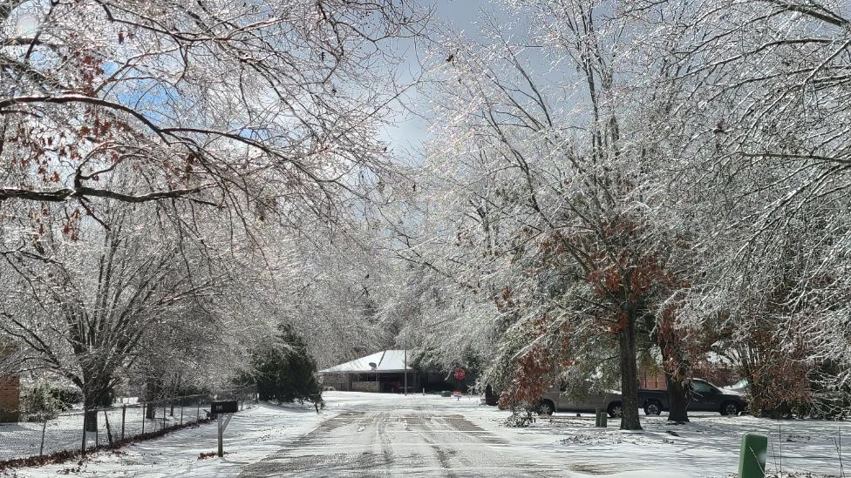
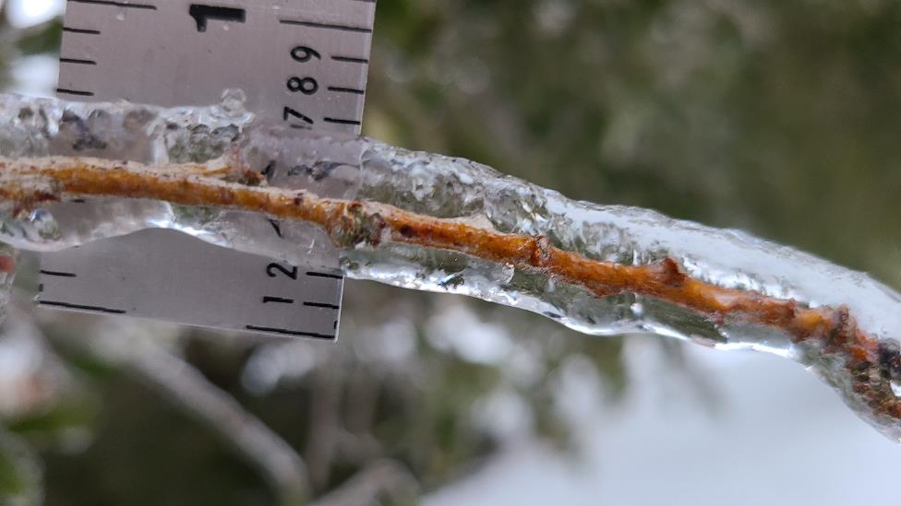

References/Sources

Bayou State Weather, LLC: www.bayoustateweather.com
Green, Burt
Iowa State University: www.mesonet.agron.iastate.edu
Louisiana Office of State Climatology: www.losc.lsu.edu
National Weather Service – Shreveport: www.weather.gov/shv
NOAA: National Centers for Environmental Information (NCDC): www.ncdc.noaa.gov
Pivotal Weather: www.pivotalweather.com
Plymouth State University: www.vortex.plymouth.edu
PowerOutage.us: www.poweroutage.us
University of Wyoming: www.weather.uwyo.edu
Weather Models: www.weathermodels.com

